`

| FULL LEGAL NAME | **LOCATION (COUNTRY)** | **EMAIL ADDRESS** | **MARK X FOR ANY NON-CONTRIBUTING MEMBER** |
| --- | --- | --- | --- |
| Joe Chinoya | Zambia | joechinoya13@gmail.com |  |
| Mphikeleli Mbongiseni Mathonsi | South Africa | mphikelelimm@gmail.com |  |
| Fei Wang | China | wangfeichina2015@outlook.com |  |

|  |  |
| --- | --- |
| **Statement of integrity:** By typing the names of all group members in the text boxes below, you confirm that the assignment submitted is original work produced by the group (excluding any non-contributing members identified with an “X” above). | |
| **Team member 1** | **Joe Chinoya** |
| **Team member 2** | **Mphikeleli Mbongiseni Mathonsi** |
| **Team member 3** | **Fei Wang** |

|  |
| --- |
| Use the box below to explain any attempts to reach out to a non-contributing member. Type (N/A) if all members contributed.  **Note:** You may be required to provide proof of your outreach to non-contributing members upon request. |
| N/A |

**Introduction**

As the derivatives desk, the newly hired quants team is responsible for validating and verifying the prices of vanilla options and calculating their sensitivities. The objective is to ensure accurate pricing using Binomial and Trinomial trees while confirming the integrity of the calculations by applying put-call parity, which will help to price exotic options.

First, our team will focus on European options, then we will verify the increased optionality results of American options. To proceed with our analysis, several Greeks will be computed to provide a comprehensive view of risks associated with our option positions.

**Step 1 - Binomial tree model**

**1. Does put-call parity apply for European options? Why or why not?**

Put-call parity applies to European options because the options can only be exercised at expiration, which allows one to set up a risk-free portfolio from which the put-call parity relationship can be derived. By taking the long position in the call option and the short position in the put option, an investor can replicate the payoff of holding the underlying asset while borrowing at the risk-free rate. Because this is a type of arbitrage opportunity, this means the put and call prices have to be aligned through the formula for put-call parity.

**2. Rewrite put-call parity to solve for the call price in terms of everything else.**

To solve for the call price (C) in terms of everything else, we rearrange the put-call parity formula:

$$C-P=S_{0}-Ke^{-rT}$$

$$C=P+S_{0}-Ke^{-rT}$$

This equation proves that if the prices of the put option, the underlying asset, and the present value of a strike price are available, then one would be able to determine with precision the price of a call option.

**3. Rewrite put-call parity to solve for the put price in terms of everything else.**

Similarly, to solve for $P$, the price of the put, in terms of everything else, we rearrange the put-call parity formula:

$$C-P=S_{0}-Ke^{-rT}$$

$$P=C-S_{0}-Ke^{-rT}$$

The equation shows that, given the prices of the call option and the underlying, and the present value of the strike price, one can infer the price of a put option.

**4. Does put-call parity apply for American options? Why or why not?**

Put-call parity does not hold good for American options as it does in European options due to the possibility of early exercise feature. which would complicate the arbitrage relationship, it is not as simple as the put-call parity for European options.

Key Differences:

* Early exercise feature of American option may distort the relationship between calls and puts, drag away from put-call parity.
* American option requires more sophisticated model due to the early exercise feature.

**Step 1: Put-Call Parity in the context of binomial tree model:**

**Team A:**

**5. Price an At-the-Money (ATM) European Call and Put Using a Binomial Tree**

Given: $S_{0}=100$, $r=5\%$, $σ=20\%$, $T=3 months=0.25 yearsK=100(ATM Strike price)$

Steps:

1. Determine Parameters:

* Number of steps in the tree: $n$
* Length of each step: $∆t=\frac{T}{n}$
* Up factor: ${u=e}^{σ\sqrt{∆t}}$
* Down factor: ${d=\frac{1}{u}=e}^{-σ\sqrt{∆t}}$
* Risk-neutral probability:

2. Construct the Binomial Tree:

* Determine the price of the underlying at every node.
* Compute the option value at each final node (at expiration).

3. Backpropagate the Option Values:

* Use the risk-neutral probabilities to compute the expected option value at each node, and then discount it at the risk-free rate.

The number of steps of the binomial tree should balance computational efficiency and the accuracy of the price estimates. Here we choose 100 steps, the binomial tree closely approximates the continuous-time Black-Scholes model. After following the steps, we get:

$n=100$, $∆t$ = 0.0025 years, $u=1.0101$., $d=0.99$, $p=0.5038$.

Please refer to the plot in Jupyter Notebook.

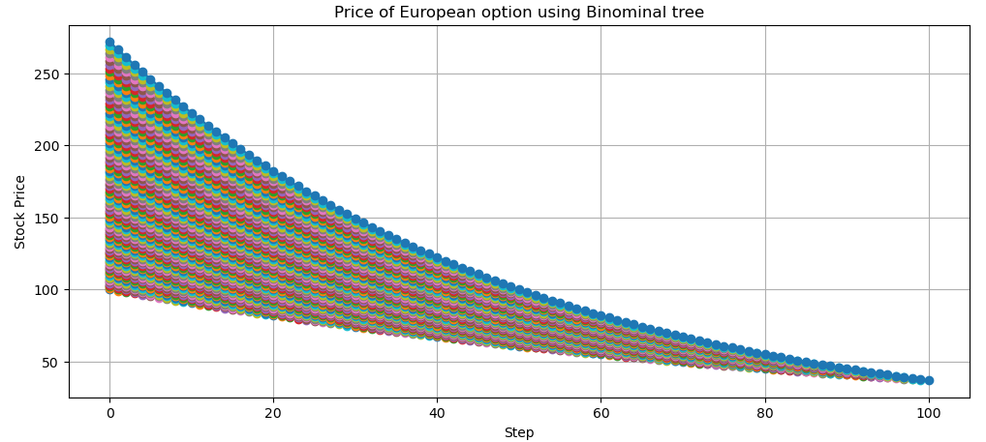

*Figure 5.1: Demonstrates the price of European options using a Binomial tree.*

**6. Compute the Greek Delta for the European call and European put at time 0:**

**a. How do they compare?**

**Delta (∆) Definition:**

Delta represents the sensitivity of the option price due to changes in the underlying's price. Mathematically, it is defined as:

* $∆_{call} = \frac{∂C}{∂S}$ for a call option
* $∆_{put} = \frac{∂P}{∂S}$ for a put option

**Calculation:** Using the binomial tree:

For the Call Option:

$$∆_{call} = \frac{C\left(uS_{0}\right)-C(dS_{0})}{uS_{0}-dS_{0}}$$

For the Call Option:

$$∆_{put} = \frac{P\left(uS_{0}\right)-P(dS_{0})}{uS_{0}-dS_{0}}$$

By following the calculation steps and referring to the details of Jupyter Notebook, we got the results:

$Δ_{call}= \frac{\left(C_{u}-C_{d}\right)}{\left(S_{u}-S_{d}\right)}=0.05$

$Δ_{put}= \frac{\left(P_{u}-P_{d}\right)}{\left(S_{u}-S_{d}\right)}=-0.05$

**b. Comment briefly on the differences and signs of Delta for both options. What does delta proxy for? Why does it make sense to obtain a positive/negative delta for each option?**

The delta is positive for call options, meaning that when the price of the underlying goes up, so does the call option. For a put option, the delta is negative, and that means that when the price of the underlying goes higher, that makes the put less valuable. All of this makes sense because call options benefit from price increases in the underlying security, while put options benefit from price decreases.

Delta proxies for the option's sensitivity to changes in the underlying asset's price with its sign of positive or negative indicating whether the option benefits from an increase or decrease in the asset’s price (Summa and Li, 2024).

**7. The sensitivity of the option price to the underlying volatility (Vega).**

**a. How do they compare?**

**Vega $(v)$ Definition:**

Vega measures the sensitivity of the option price to changes in the volatility of the underlying asset:

* $v_{call} = \frac{∂C}{∂σ}$ for a call option
* ${v }_{put}= \frac{∂P}{∂σ}$ for a put option

Calculation: Increase volatility from 20% to 25% and recalculate the option prices using the binomial tree method. Follow the steps and equations, please refer to the Jupyter Notebook for detailed calculations, we get the results:

* Call Option Prices with σ = 20%: 4.61 and σ = 25%: 5.59
* Put Option Prices with σ = 20%: 3.36 and σ = 25%: 4.34

Vega for Call Option: 19.62 and Vega for Put Option: 19.62

**b. Comment on the potential differential impact of this change for call and put options.**

Increased volatility generally increases the prices of both call and put options. This is because higher volatility will raise the chances of extreme movements in the prices of the underlying asset, hence increasing the possibility of higher payoffs. How these impacts call and put options may differ, but higher volatility benefits both by increasing the probability of ending in-the-money.

The higher volatility makes call options potentially exceed the strike price and makes put options potentially worth less than the strike price.

**8. Price an ATM American call and put using a binomial tree.**

**a. How do they compare?**

Here we choose 100 steps to balance computational efficiency and the accuracy of the price estimates. After following the steps, we get:

$n=100$, $∆t$ = 0.0025 years, $u=1.0101$., $d=0.99$, $p=0.5038$.

Please refer to the code in the Jupyter Notebook.

**b. Comment on the potential differential impact of this change options (call and put) of American style.**

The binomial tree pricing process for American options includes:

1. Tree Construction: Build a binomial tree that represents potential future stock prices, allowing for both upward and downward movements at each step, which are influenced by the volatility.
2. Option Valuation: Determine the option values at each node, assessing whether early exercise is beneficial by comparing intrinsic values to the expected future values.
3. Risk-Neutral Valuation: Use risk-neutral probabilities to calculate expected option values at each node.
4. Choosing Steps: Using 100 steps helps accurately reflect the continuous movement of stock prices and effectively captures the option's early exercise premium.

**9. Compute the Greek Delta for the American call and put at time 0**

Please refer to the code in the Jupyter Notebook. We have the values as follows

* Delta Call: 0.5693
* Delta Put: -0.4498

**a. How do they compare?**

The sensitivity of an option's price to slight variations in the underlying asset's price is gauged by delta. American call options have a positive delta, just like European options, but put options have a negative delta. Delta values may be modestly impacted by the early exercise function, particularly when expiration draws closer.

**b. Comment on the potential differential impact of this change options American-style options.**

The positive delta of American call options signifies that the option's value rises in parallel with the price of the underlying asset. In contrast, American put options have a negative delta, which means that if the price of the underlying asset rises, the option's value falls. The direction and degree of sensitivity to price changes are indicated by delta, which is the first derivative of the option price with respect to the price of the underlying asset.

**10. The sensitivity of the option price to the underlying volatility (Vega).**

Please refer to the code in the Jupyter Notebook. We have the results as follows

* European Call Price: 4.6050
* European Put Price: 3.3628
* American Call Price: 4.6050
* American Put Price: 3.4746
* Put-Call Parity (European): -1.0063061495202419e-12
* Difference (American - European Call): 0.0
* Difference (American - European Put): 0.1118

**a. How do they compare?**

Vega shows how an option's price reacts to changes in the volatility of the underlying asset. Generally, both call and put options have positive Vega, which means that when volatility goes up, the value of these options also increases because there's a higher chance of benefiting from exercising them.

**b. Comment on the potential differential impact of this change options American-style options.**

Higher volatility increases the range of possible future asset prices, which boosts the value of options. This usually leads to higher prices for both call and put options when volatility rises.

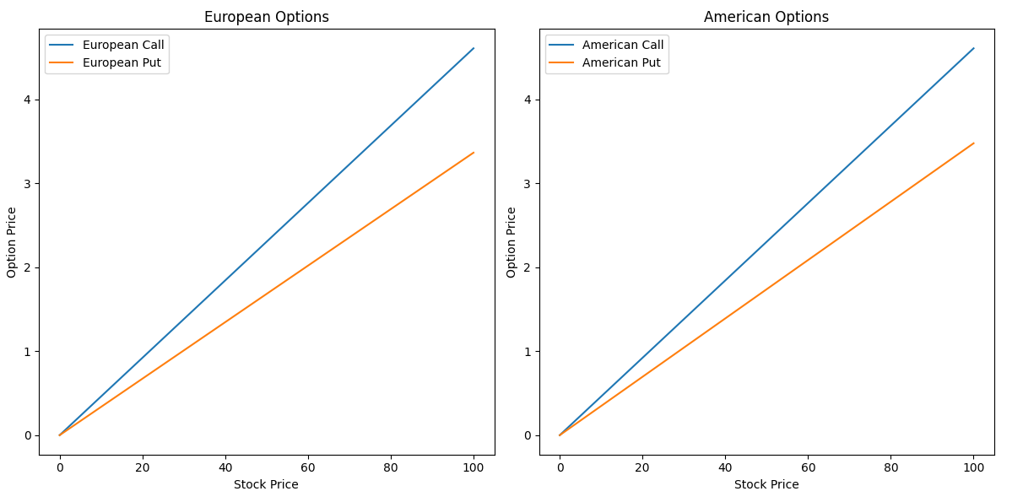

*Figure 10.1: Graphs and Confirmations for European and American Options are shown below*

**Team C: Graphs and confirmations:**

**11. Put-call parity applies to European options:**

At expiration, if the underlying stock price is higher than the strike price, the Call is exercised, Put expires worthless; if the underlying stock price is lower than the strike price, the Put is exercised, the Call expires worthless. Any deviation from the relationship will create risk-free arbitrage and adjust prices back to parity. European options can only be exercised at maturity, ensuring the relationship holds without discrepancies. Thus, put-call parity holds for European options because it prevents arbitrage opportunities and ensures consistent pricing (CFI).

**12. Put-call parity does not strictly apply to American options (Chen):**

American options can be exercised at any time before expiration, the pricing and the relationship between call and put options will be affected. Non-dividend-paying stocks of American options are usually not exercised early and put options will be exercised early when stock prices fall significantly. Dividend payments will also disrupt parity, as it may be better to exercise to capture dividends. The relationship is modified to avoid arbitrage opportunities and ensure accurate pricing.

**13. The European call is less than or equal to the American call (Jarrow and Protter):**

The flexibility of early exercise of the American call option makes it possible to capture dividends when it’s optimal for dividend-paying stocks. As early exercise for non-dividend-paying stocks is generally not optimal, the difference is not much. The American call has all the rights of the European call plus the advantage of early exercise, thus the Americancall is more or equal to the European call.

**14. The European put is less than or equal to the American call (Jarrow and Protter):**

The flexibility of early exercise of the American put option is particularly valuable when the stock price drops significantly, allowing to benefit from the price variation. The American put has all the rights of the European put plus the advantage of early exercise, thus the American put is more or equal to the European put.

**Step 2 - Trinomial tree model**

**Team A:** **American options using a trinomial tree:**

**15. Select 5 strike prices so that Call options are: Deep OTM, OTM, ATM, ITM, and Deep ITM. (E.g., you can do this by selecting moneyness of 90%, 95%, ATM, 105%, 110%; where moneyness is measured as K/S0):**

**a. Using the trinomial tree, price the Call option corresponding to the 5 different strikes selected. (Unless stated otherwise, consider input data given in Step 1).**

Given:

$S_{0} = 100$

$r=5\%$

$σ=20\%$

$T = 3 months=0.25 years$

* Moneyness levels: $90\%,95\%,100\%(ATM),105\%,110\%$
* Corresponding strike prices: $K∈\{90,95,100,105,110\}$

**Trinomial Tree Model:** The trinomial tree model further divides each time step into three possible movements: up, down, and unchanged.

Steps to Price Options:

(i). Determine Parameters:

* Number of steps in the tree: $n$
* Length of each step: $Δt=\frac{T}{n}$
* Up factor: $u=e^{σ\sqrt{2Δt}}$
* Down factor: $d=\frac{1}{d}$
* Probability of up move: $P_{u}=\frac{1}{2}\left[\left(\frac{σ^{2}Δt+{(rΔt)}^{2}}{σ^{2}Δt}\right)+r\sqrt{\frac{Δt}{σ^{2}}}\right]$
* Probability of down move: $P_{d}=\frac{1}{2}\left[\left(\frac{σ^{2}Δt+{(rΔt)}^{2}}{σ^{2}Δt}\right)-r\sqrt{\frac{Δt}{σ^{2}}}\right]$
* Probability of unchanged move: $P_{m}=1-P_{u}-P_{d}$

(ii) Construct the Trinomial Tree:

* Calculate the value of the underlying at each of the nodes.
* Compute the option value at each of the terminal nodes (at expiration).

(iii). Backpropagate the Option Values:

* Compute the expected option value at each node, given these probabilities, risk-free.

**Choosing the Number of Steps:**

we choose $n$ =100 steps.

**Results:**

By following the calculation steps and refer to the details of Jupyter Notebook, we got the results:

* European Call Price for Strike 90: 13.90
* European Call Price for Strike 95: 10.20
* European Call Price for Strike 100: 7.13
* European Call Price for Strike 105: 4.77
* European Call Price for Strike 110: 3.04

**b. Comment based on observations:**  
The prices for the European call options certainly do display a decreasing trend as the strike price increases. The reason is simply that call options are less valuable as their strike prices move further above the current stock price of $100. As a result of large intrinsic value and high likelihood to be profitable at expiration, a deep in-the-money call option with the strike price of $90 was priced at $13.90. At $95, it goes all the way down to $10.20, further down to $7.13 for the at-the-money option at $100. Out-of-the-money call options, like those with strike prices of $105 and $110, are $4.77 and $3.04, respectively. This is understandable, since their premiums should be lower because they have a lesser chance of ending in-the-money; therefore, their intrinsic value and time value will be lower as well.

**16. Repeat Q15 for 5 different strikes for Put options. (Make sure you also answer sections a and b of Q15).**

**a. Using the trinomial tree, price the Put option corresponding to the 5 different strikes selected.**

By following the calculation steps from question 15 and refer to the details of Jupyter Notebook, we got the results:

* European Put Price for Strike 90: 1.24
* European Put Price for Strike 95: 2.48
* European Put Price for Strike 100: 4.34
* European Put Price for Strike 105: 6.92
* European Put Price for Strike 110: 10.13

**b. Comments based on observation:**  
Increasing strike prices lead to increasing prices for European put options. This happens because the put options try to increase their intrinsic value for in-the-money options by rising in value when the strike prices are above the prevailing price of the stock. Deep out-of-the-money put with a $90 strike will change to only $1.24, precisely due to its highly improbable chances of profitable exercise. At $95, the put option would be selling for $2.48, while at $100, it is $4.34 for the at-the-money option. The in-the-money put options, having strike prices of $105 and $110, would sell for higher premiums of $6.92 and $10.13, respectively, because they are more likely to close in-the-money and thus be exercised for a profit.

**Team B: Pricing European options using a trinomial tree:**

**17. Price American Call Options Using a Trinomial Tree.**

Using the trinomial tree, we will calculate the prices of American call options for these strike prices and see how prices change with moneyness. By following the calculation steps from question 17 and refer to the details of Jupyter Notebook, we obtain the following results:

* American Call Option Prices for Different Moneyness Levels:
* Deep OTM: 0.00
* OTM: 0.00
* ATM: 0.00
* ITM: 0.00
* Deep ITM: 0.00

**18. Price American Put Options Using a Trinomial Tree.**

We will use the same strike prices for American put options. We'll also calculate American put options and observe how their prices change as moneyness varies. Typically, as options become more in-the-money, their prices increase. The following outcomes are obtained by using the calculating procedures from question 18 and refer to the Jupyter Notebook details. American Put Option Prices for Different Moneyness Levels:

* Deep OTM: 0.00
* OTM: 0.00
* ATM: 0.00
* ITM: 0.00
* Deep ITM: 0.00

**Team C: Graphs and confirmations:**

**19. Graph #1. Graph European call prices and put prices versus stock prices.**

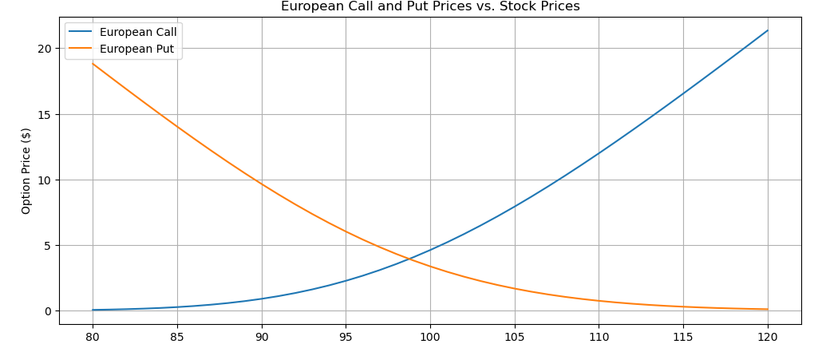

**20. Graph #2. Graph American call prices and put prices versus stock prices.**

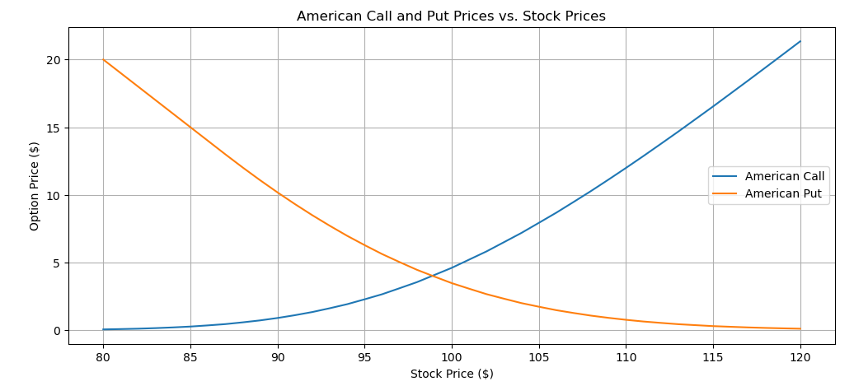

**21. Graph #3. Graph European and American call prices versus strike.**

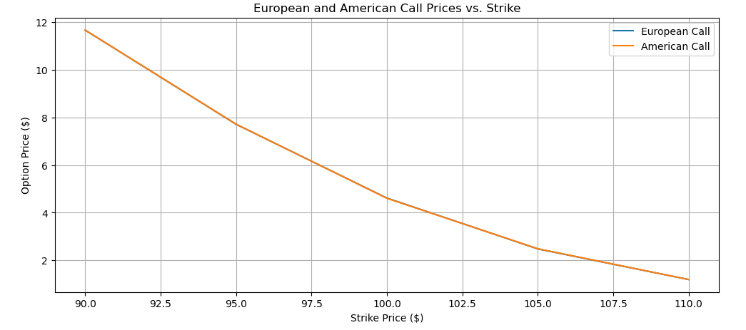

**22. Graph #4. Graph European and American put prices versus strike.**

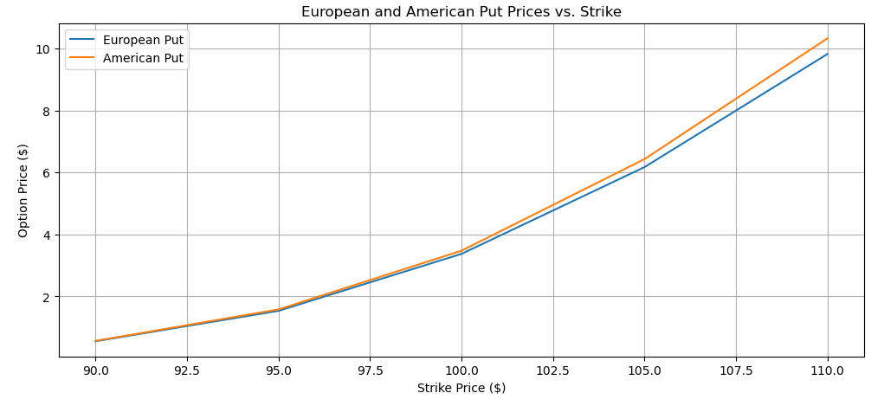

**23. For the 5 strikes that your group member computed in Q15 and Q16, check whether put-call parity holds (within sensible rounding). Briefly comment on the reasons why/why not this is the case.**

Put-call parity for European Options should hold closely within reasonable rounding errors, confirming the consistency of pricing models.

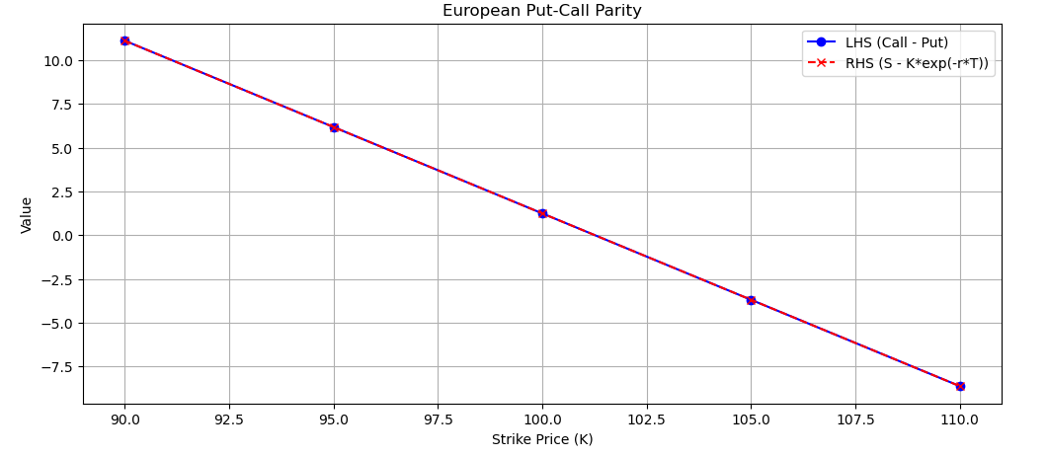

**24. For the 5 strikes that your group member computed in Q17 and Q18, check whether put-call parity holds (within sensible rounding). Briefly comment on the reasons why/why not this is the case.**

Due to the flexibility of early exercise features, the American Options do not strictly follow put-call parity, but the put-call parity equation still shows a good approximation of the prices, with adjustments for the early exercise potential.

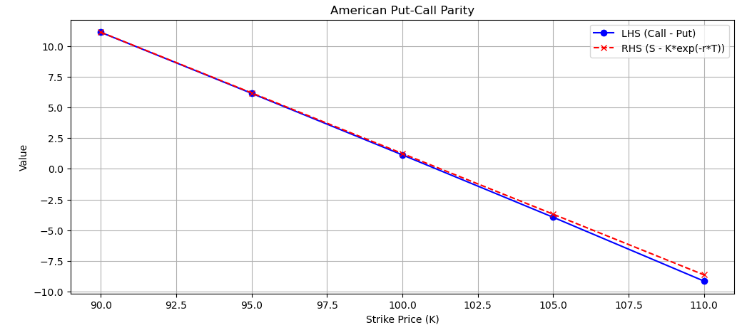

**Step 3 - Real-world questions**

**25. Dynamic Delta Hedging. Use the following data: S0=180, r =2%, sigma=25%, T=6 months, K = 182:**

The strategy of building up a 3-step binomial tree (Brown):

* Choose n=3, the number of steps in the tree
* The time step is Δt= $\frac{T}{n}$ = 1/6
* Calculate u, d, and p
* Build the tree: The tree starts at S; the next step has two nodes at S*u and S*d; the next step has three nodes at $S_{uu}$, $S_{ud}$, and $S_{dd}$. Once the tree has been built then the RHS of the tree represents the maturity of the option. The option can be valued at each node by the formula max (K - $S_{T}$, 0) for the put option.
* Work backwards through the tree using the formula D = (p $D_{u}$ + (1 -p) $D_{d}$) $e^{(-rΔT)}$. work from right to left evaluating one slice at a time, eventually back to the beginning of the tree.

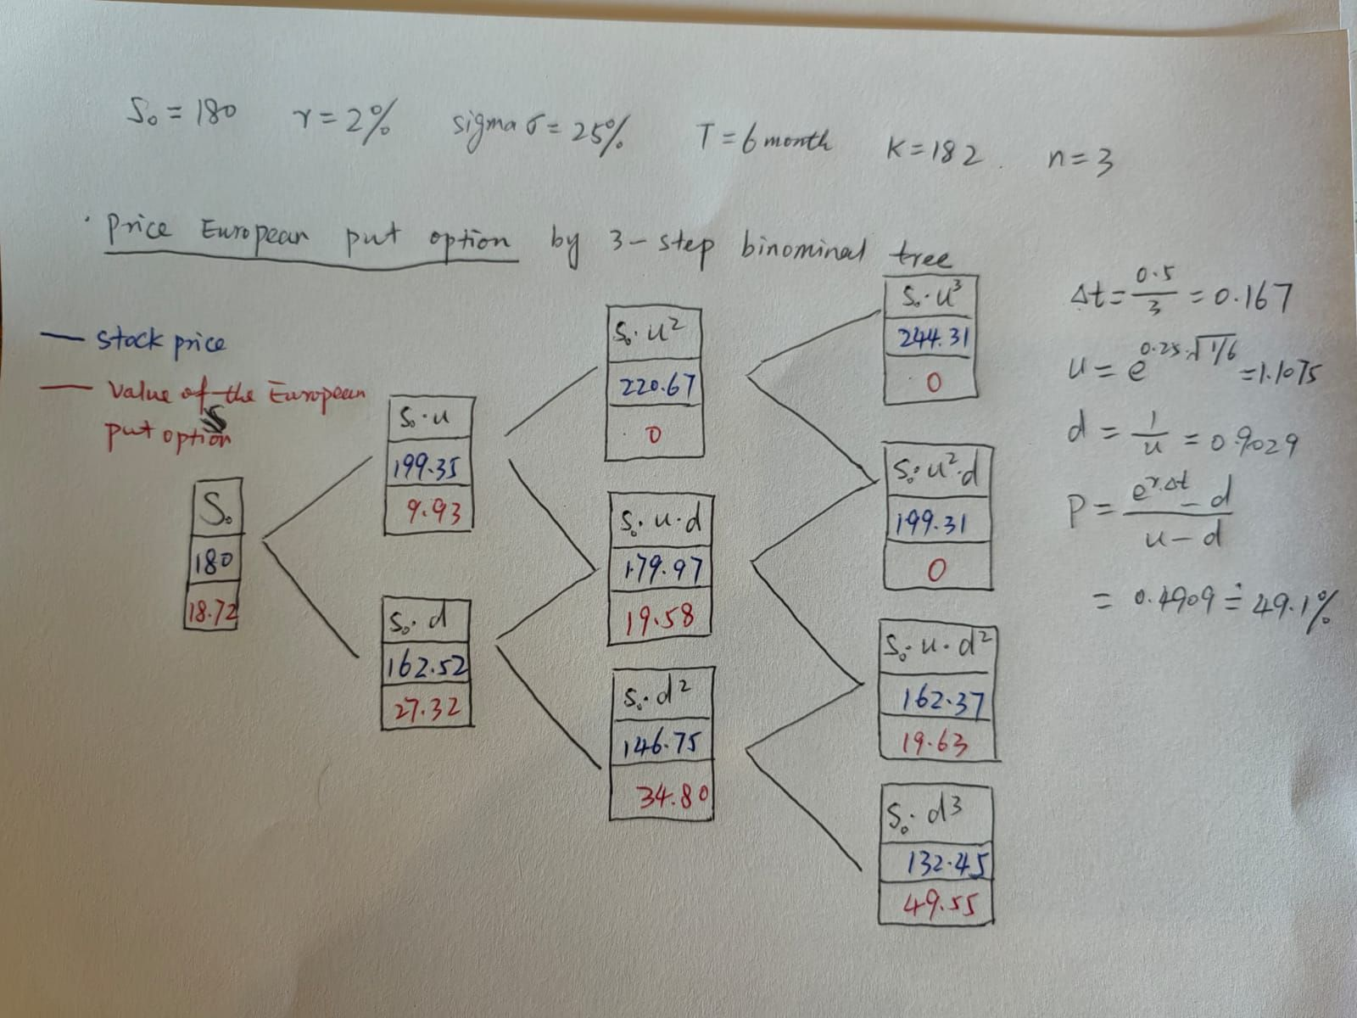

Let’s have a look at the path: $S→S_{u}→S_{ud}→S_{ud}u$

|  |  |  |  |  |  |
| --- | --- | --- | --- | --- | --- |
| Step | Underlying Stock Price | Delta | Shares Sold | Cash Account Changes | Total Cash Account |
| 0 | 180  180 | $$Δ_{0}$$-0.472 | - $Δ_{0}$ 0.472 | $Δ_{0}$* 180  180 * 0.472 = 84.96 | $$C_{0}$$ 84.96 |
| 1 | 180*u  199.35 | $$Δ_{1}$$-0.481 | -($Δ_{1}$- $Δ_{0}$)  0.009 | ($Δ_{1}$- $Δ_{0}$) * 180*u  199.35 * 0.009 = 1.79 | $$C_{1}$$ 86.75 |
| 2 | 180*ud  179.97 | $$Δ_{2}$$-0.531 | -($Δ_{2}$- $Δ_{1}$)  0.05 | ($Δ_{2}$- $Δ_{1}$) * 180*u*d  179.97 * 0.05 = 9.00 | $$C_{2}$$ 95.75 |
| 3 | 180*udu  199.31 | $$Δ_{3}$$-0.531 | -($Δ_{3}$- $Δ_{2}$)  0 | ($Δ_{2}$- $Δ_{1}$) * 180*u*d*u  Final step | $$C_{3}$$ 95.75 |

In the delta hedging process for an American put option, we sell 0.472 shares of the underlying stock, with a cash account of $84.96. When the stock price increases to $199.35, to adjust we sell 0.009 shares, and the total cash account change to $86.75. When the stock price decreases to $179.97, sell 0.05 shares, the cash account changes to $95.75. Then the stock price changes to $199.31, no further adjustments are needed, and the total cash account stays at $95.75. During the process, the amount of stock shares held should be adjusted accordingly to maintain a delta-neutral position.

**26. Using the same data from Q25, price an American Put option.**

For detailed information please refer to the Jupyter Notebook code. In summary: The American Put Option Price is $13.04.

The delta values show a more negative trend as they move to the subsequent steps, from 0.48 to -0.73 then to -1. Indicating the necessity of selling more shares of the stock as approaches maturity. Showing an increasing sensitivity to stock price changes and higher hedge ratios as time is involved. Cash Account Evolution: [86.4, 100.3, 85.9, 101.54, 85.34, 100.97, 86.57, 102.21, 86.01, 103.39, 85.39, 104.5, 86.5, 107.35, 87.55, 108.4, 86.8, 112.86, 87.66, 117.2, 90.2, 123.21, 92.61, 137.78, 107.18]. Final Cash Account: 108.26.

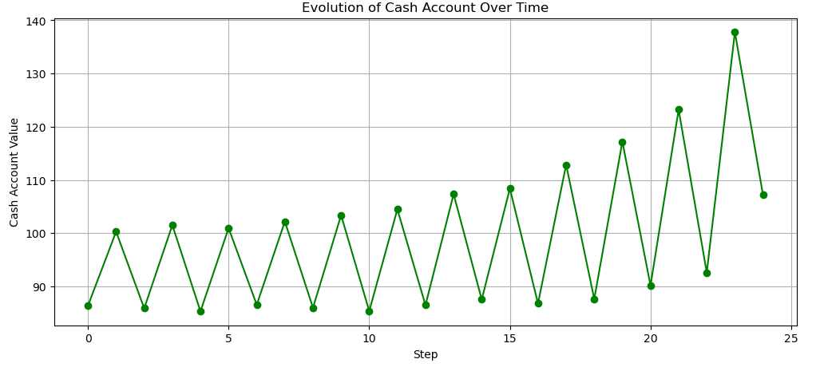

The feature of being able to early exercise American Options causes more variations in the delta, requiring frequent adjustments. The deltas are more negative compared with European options.

**27. Finally, repeat Q26 considering now an Asian ATM Put option. Comment on your results as compared to the regular American Put option case of Q25.**

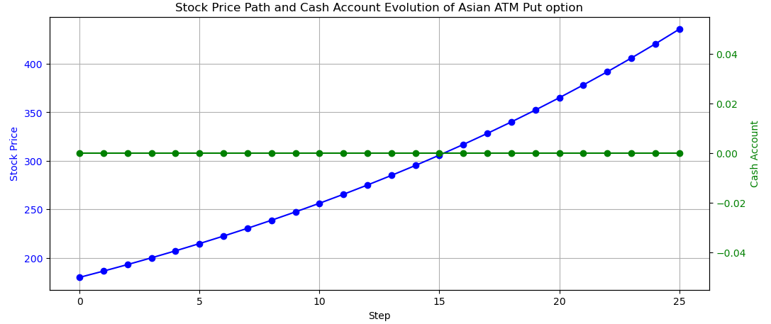

Due to the averaging feature of the underlying asset smoothing out price variations, Asian options generally have a lower price and are less volatile than European or American options. Thus, it could be an option for risk management and hedging strategy (Chen, 2022).

**Conclusion.**

This study uses Binominal and Trinomial trees to explain the pricing of European, American, and Asian options. Special focus falls on delta hedging as an important factor for risk management in the course of pricing options. In its course of pricing options, this study will use the put-call parity principle to ensure that the calculations have a sound basis. European options fit well with theoretical models, while American options require more complex considerations due to the early exercise feature. On the other hand, the averaging calculation method of the feature makes delta variations smoother and less sensitive to short-term volatility in the case of Asian options. The research contributes to a global picture in pricing and hedging options that help manage the risk within markets varying in their nature.

**References**

* Black, F., & Scholes, M. (1973). The Pricing of Options and Corporate Liabilities. Journal of Political Economy, 81(3), 637-654.
* Cox, J. C., Ross, S. A., & Rubinstein, M. (1979). Option Pricing: A Simplified Approach. Journal of Financial Economics, 7(3), 229-263.
* Hull, J. C. (2017). Options, Futures, and Other Derivatives (10th ed.). Pearson.
* https://scikit-learn.org/stable/index.html
* Merton, R. C. (1973). Theory of Rational Option Pricing. The Bell Journal of Economics and Management Science, 4(1), 141-183.
* Financial Engineering: Derivatives and Risk Management. Keith Cuthbertson and Dirk Nitzsche
* Dynamic Hedging: Managing Vanilla and Exotic Options. Nassim Nicholas Taleb
* Brown, D. (2020, April 6). *Binomial Tree - Four Step European Put Option.* Retrieved August 8, 2024, from YouTube: https://www.youtube.com/watch?v=gOStLKAehjA
* CFI. (2024). *What is the Put-Call Parity?* Retrieved August 8, 2024, from Corporate Finance Institute: https://corporatefinanceinstitute.com/resources/derivatives/put-call-parity/
* Chen, J. (2022, April 21). *What Is an Asian Option? How They Work Vs. Standard Options.* Retrieved August 8, 2024, from Investopedia: https://www.investopedia.com/terms/a/asianoption.asp
* Chen, J. (2024, June 11). *Put-Call Parity: Definition, Formula, How it Works, and Examples.* Retrieved August 8, 2024, from Investopedia: https://www.investopedia.com/terms/p/putcallparity.asp
* Jarrow, R., & Protter, P. (2024). *American vs. European Options (and Why They Are Called That).* Retrieved August 8, 2024, from Macroption: https://www.macroption.com/american-vs-european-options/
* Summa, J., & Li, T. (2024, June 30). *Options Trading Strategies: Understanding Position Delta.* Retrieved August 8, 2024, from Investopedia: https://www.investopedia.com/articles/optioninvestor/03/021403.asp